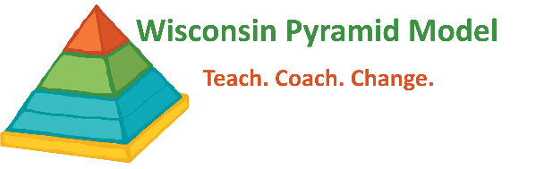
Sample PIDS Data Teacher Agreement

The Pyramid Model Implementation Data System (PIDS) is a secure web application that allows data entry, reporting, and administrative functions to be used by early childhood programs implementing the Pyramid Model in Wisconsin. As part of our program wide implementation of the Pyramid Model, our program will use PIDS to record all summary TPOT and TPITOS data. Leadership team members will review aggregate summary data from either the TPOT and/or TPITOS to guide Pyramid Model implementation in our program. Some PIDS users in our program will have access to teacher level data. Your program coach will share the data with you as part of ongoing coaching. You have the right to request information on who is able to access your data.

Program TPOT and/or TPITOS data will be shared with WI-AIMH Pyramid Model Coordination in order to report effectiveness, identify professional development gaps at the community, regional and state level, and advise on the development of resources at the state level. Your data will contribute to the quality of services for infants, toddlers and/or young children at the community, regional, state and national level. We are grateful to you for this. All shared data will be kept confidential and secure. Every person with access to PIDS must sign a User Agreement that ensures confidentiality and security provisions are followed.

I, ___________________________________, give permission for my TPOT and/or TPITOS data to be stored on the Pyramid Model Implementation Data System (PIDS). This permission remains in effect until I rescind in writing.

________________________________________________ ___________________
(Teacher) (Date)

